**Justice Party of Pennsylvania**

**Financial Report for March 2014**

**Prepared By:**   
Aaron Morris  
Treasurer

April 6, 2014

**Summary- March 2014**

**Balances**

|  |  |  |
| --- | --- | --- |
| **Account** | **Beginning Balance (on March 1)** | **Ending Balance (on March 31)** |
| Checking (Orrstown Bank) | $187.06 | $187.06 |
| PayPal | $0.00 | $0.00 |
| **Total** | **$187.06** | **$187.06** |

**Cash Flow**

|  |  |
| --- | --- |
| **Beginning Balance** (on March 1) | **$187.06** |
| Receipts |  |
| *Monetary (e.g. .cash, check, credit card)* | *$0.00* |
| *In-Kind* | *$0.00* |
| Total Receipts | $0.00 |
| Disbursements |  |
| *Operating Expenses* | *$0.00* |
| *Refunds* | *$0.00* |
| Total Expenses | $0.00 |
| **Net Change** | **$0.00** |
| **Ending Balance** (on March 31) | **$187.06** |

**Financial Analysis for March 2014**

**Income vs. Expenses by Category – March 2014**

[No financial activity ocurred in March 2014.]

**Income vs. Expenses by Payee – March 2014**

[No financial activity ocurred in March 2014.]

**Cash Flow Comparison over Prior Year**

[No financial activity ocurred in March 2014.]

**Financial Analysis for Year-to-Date**

**Income vs. Expenses by Category – YTD (Quarterly)**

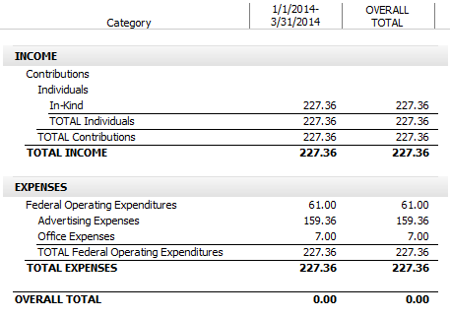

**Income vs. Expenses by Payee – YTD (Quarterly)**

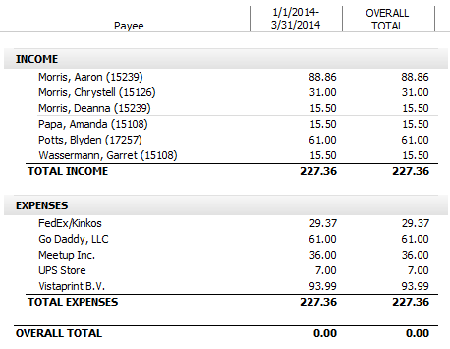

**Cash Flow Comparison over Prior Year**

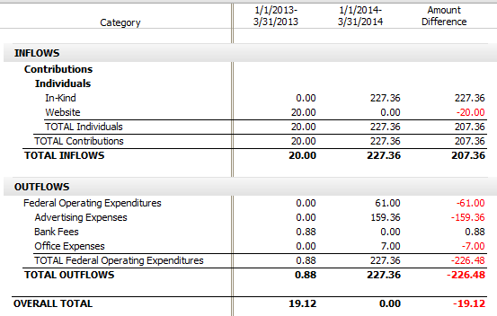

**Appendix A:   
Audit of Checking Account**